Aws : access aws Dynamodb from private subnet using VPC endpoint(no NAT gateway)

Step 1 :navigate to aws console :

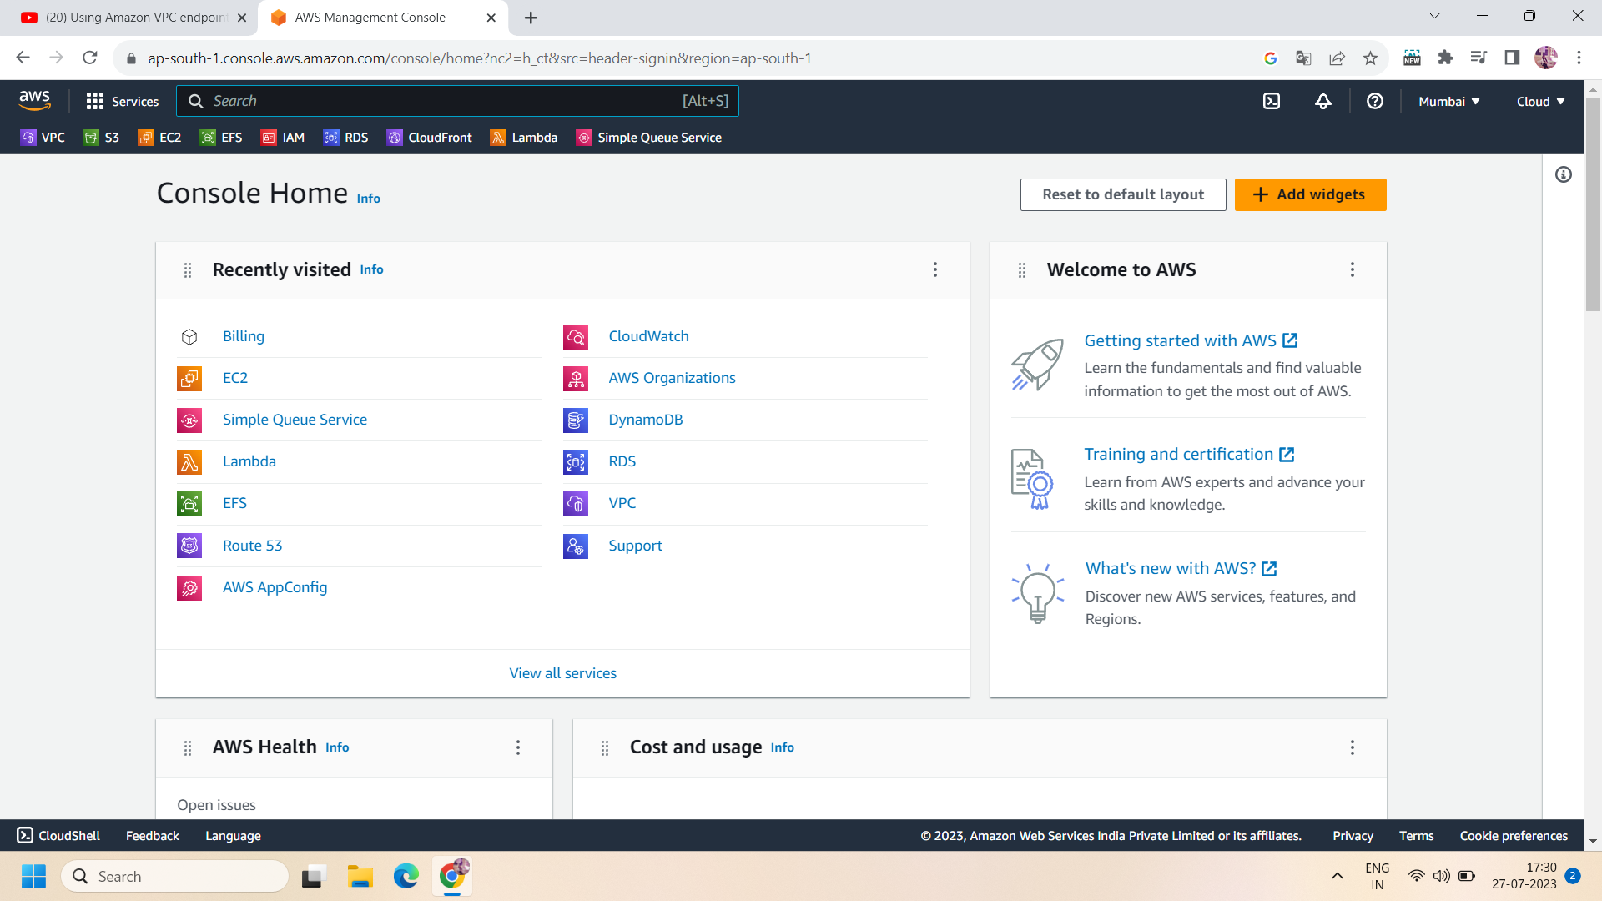

Step 2: Now navigate to VPC console and click on “Create VPC” to create a VPC:

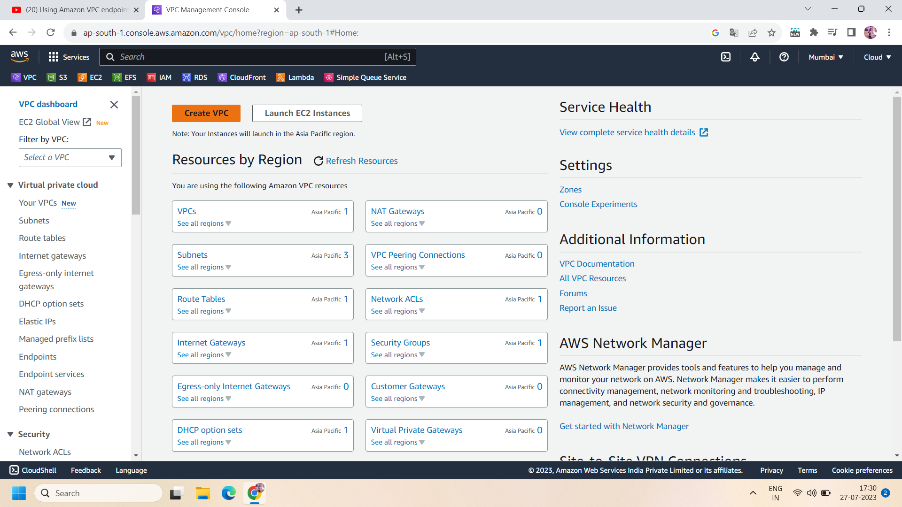

Step 3:To create a VPC,Name the VPC ,select IvP4 CIDR block and its range and click on create VPC.e.g., we choose CIDR block range - 10.0.0.0/16

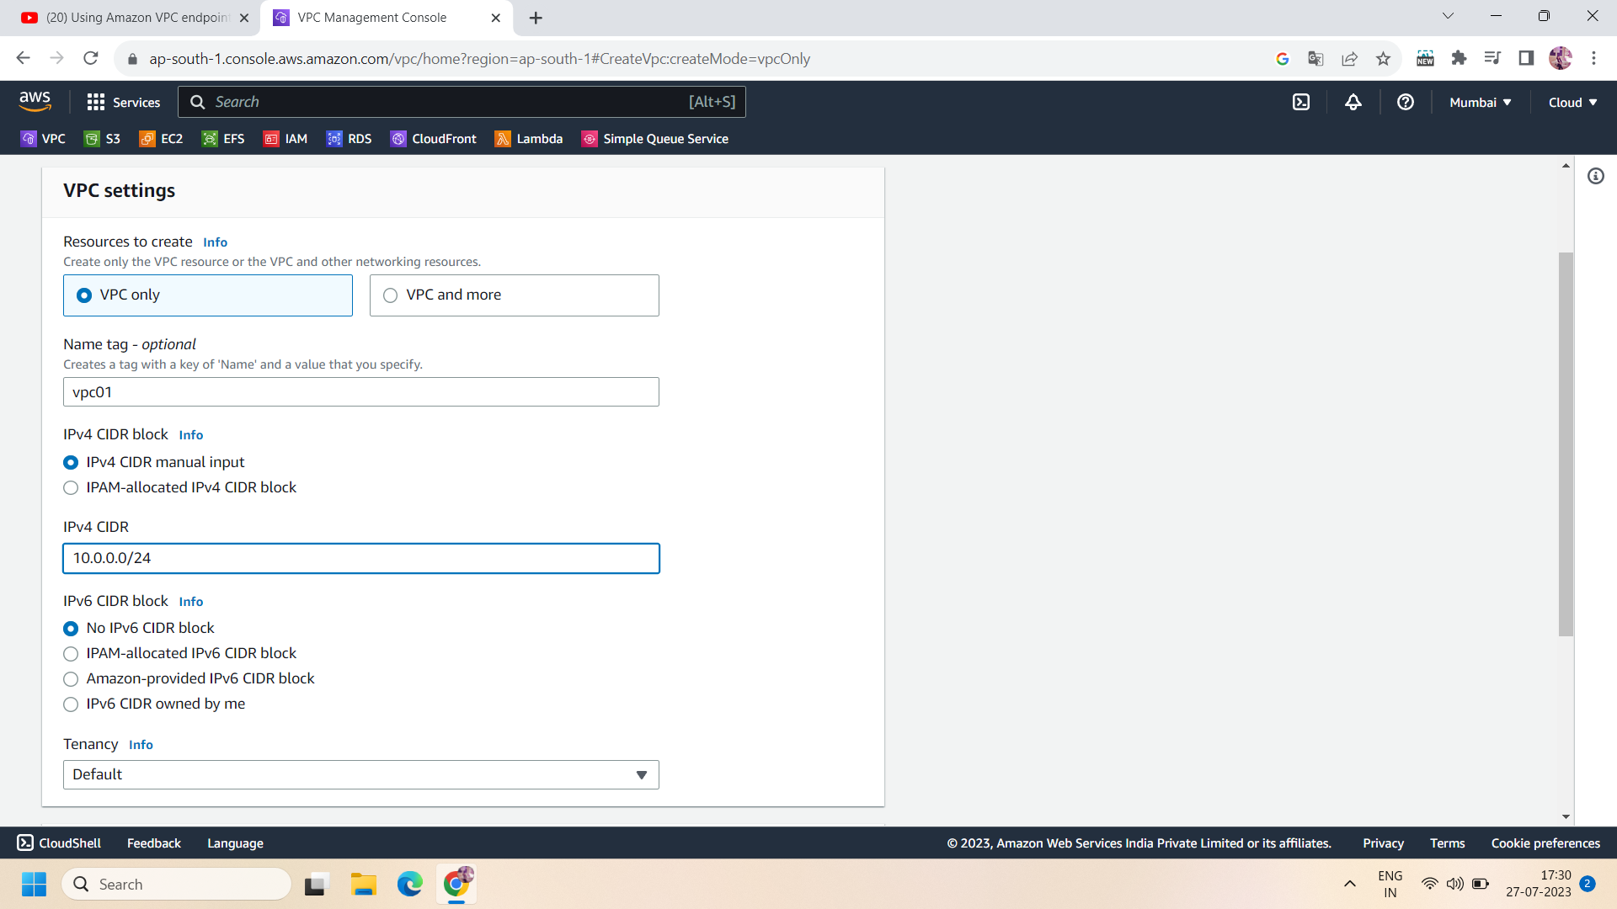

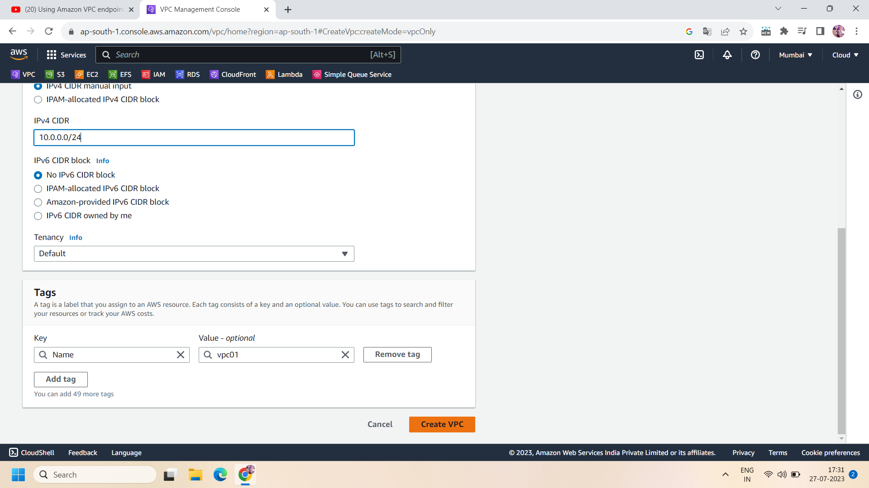

Step 4:Now ,after creating a VPC ,create two subnets : public and private subnet using the same VPC having CIDR range different e.g.,private subnet have 10.0.0.0/24 and public subnet have 10.0.1.0/24

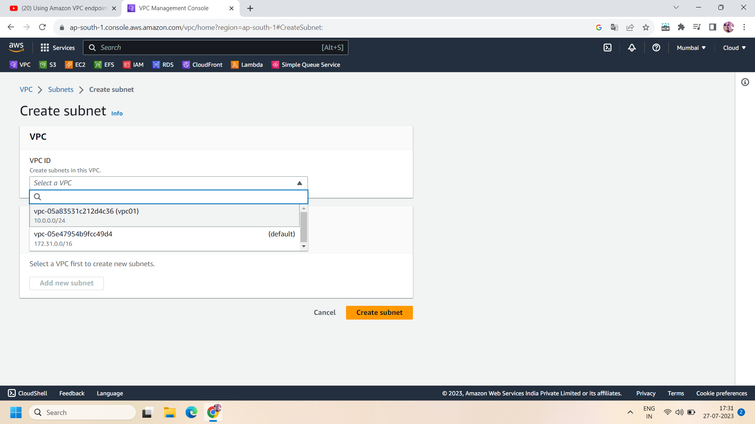

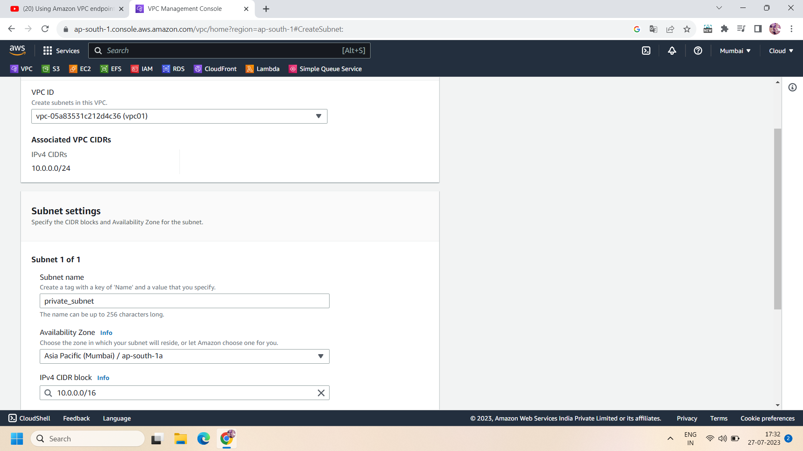

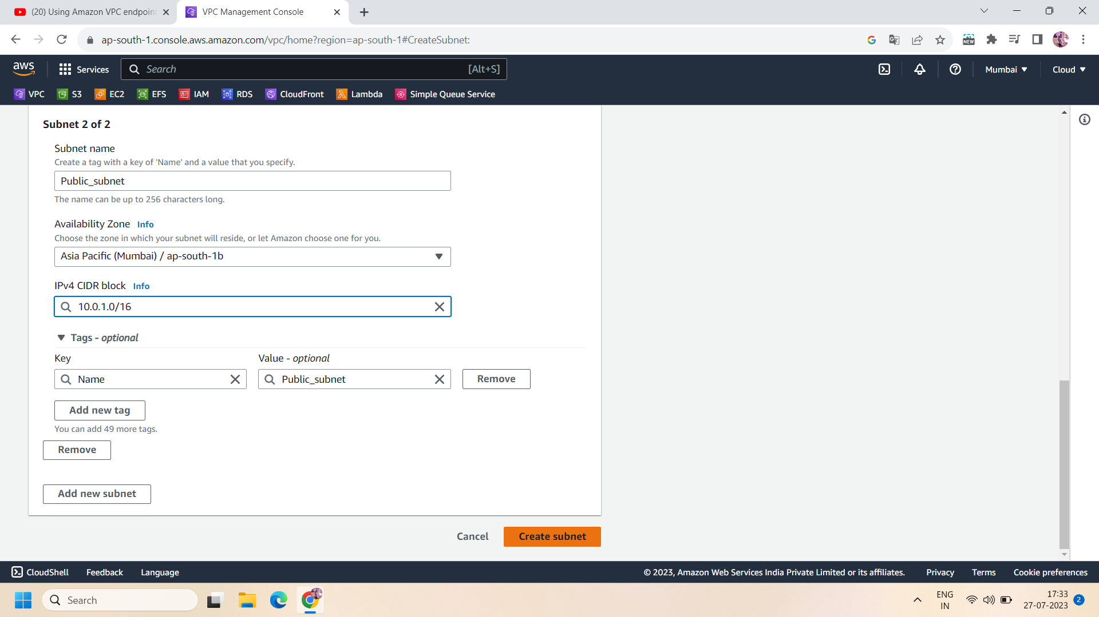

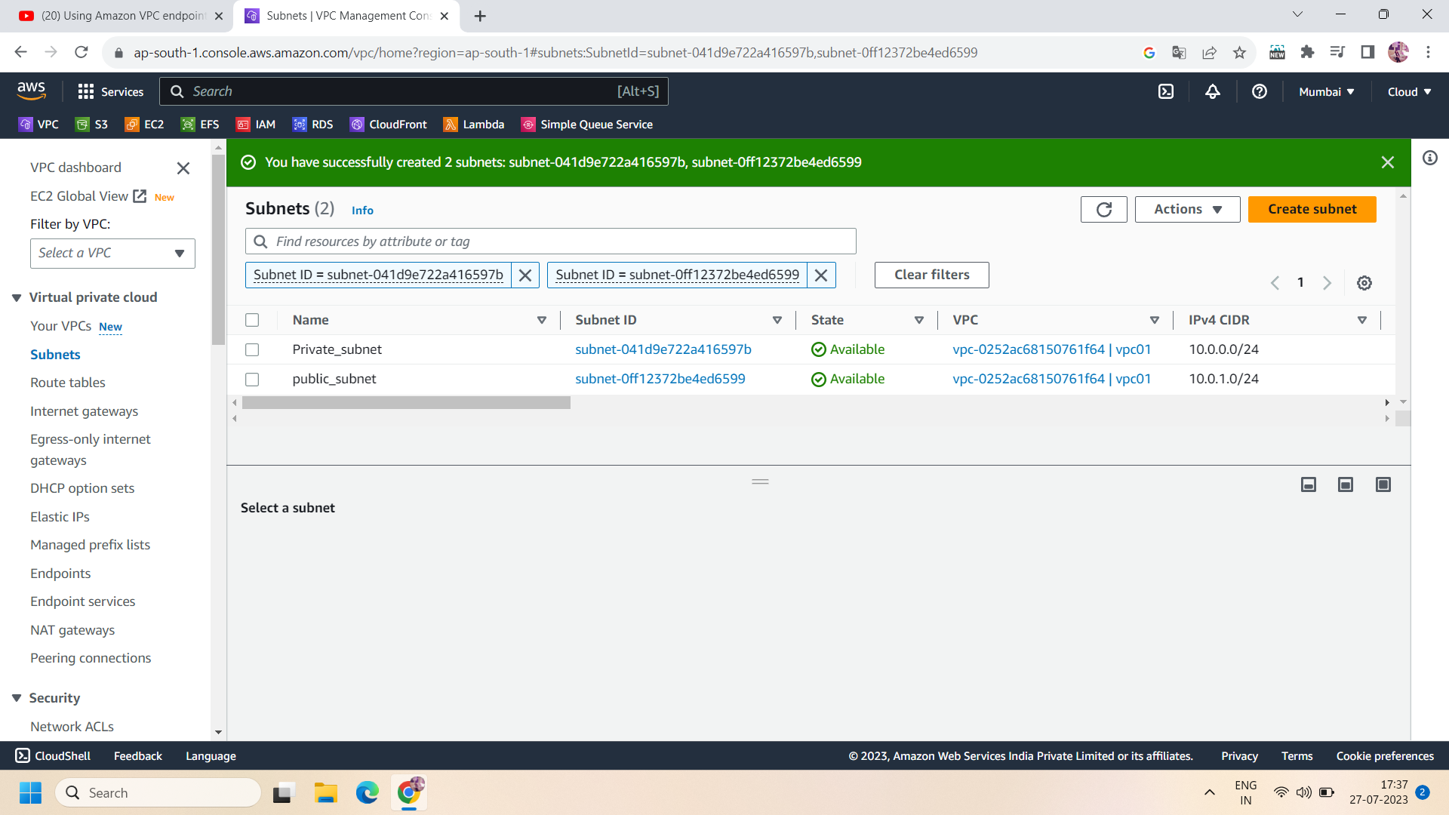

Step 5:Now create two route tables for each subnet and then associate the route table for their subnets i.e., connect the private route table with private subnet and public route table with public subnet.

* Creating private route table —>

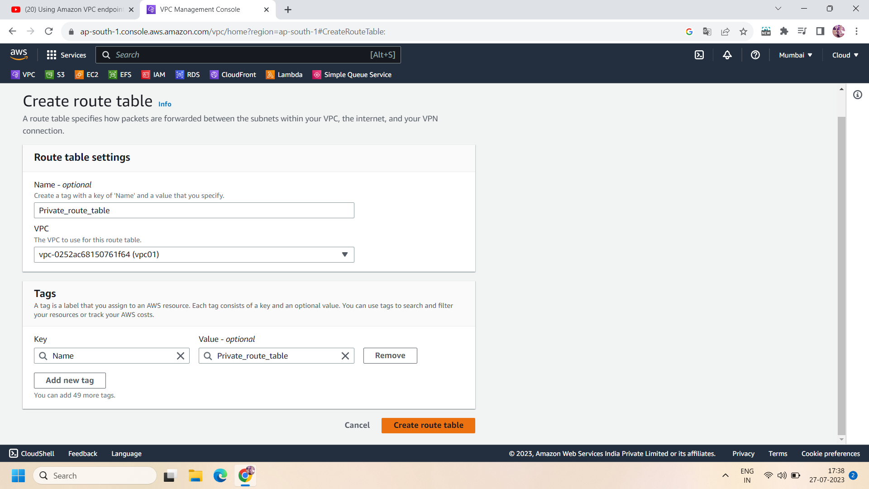

* Navigate to subnet association and connect the private subnet with a private route table.--->

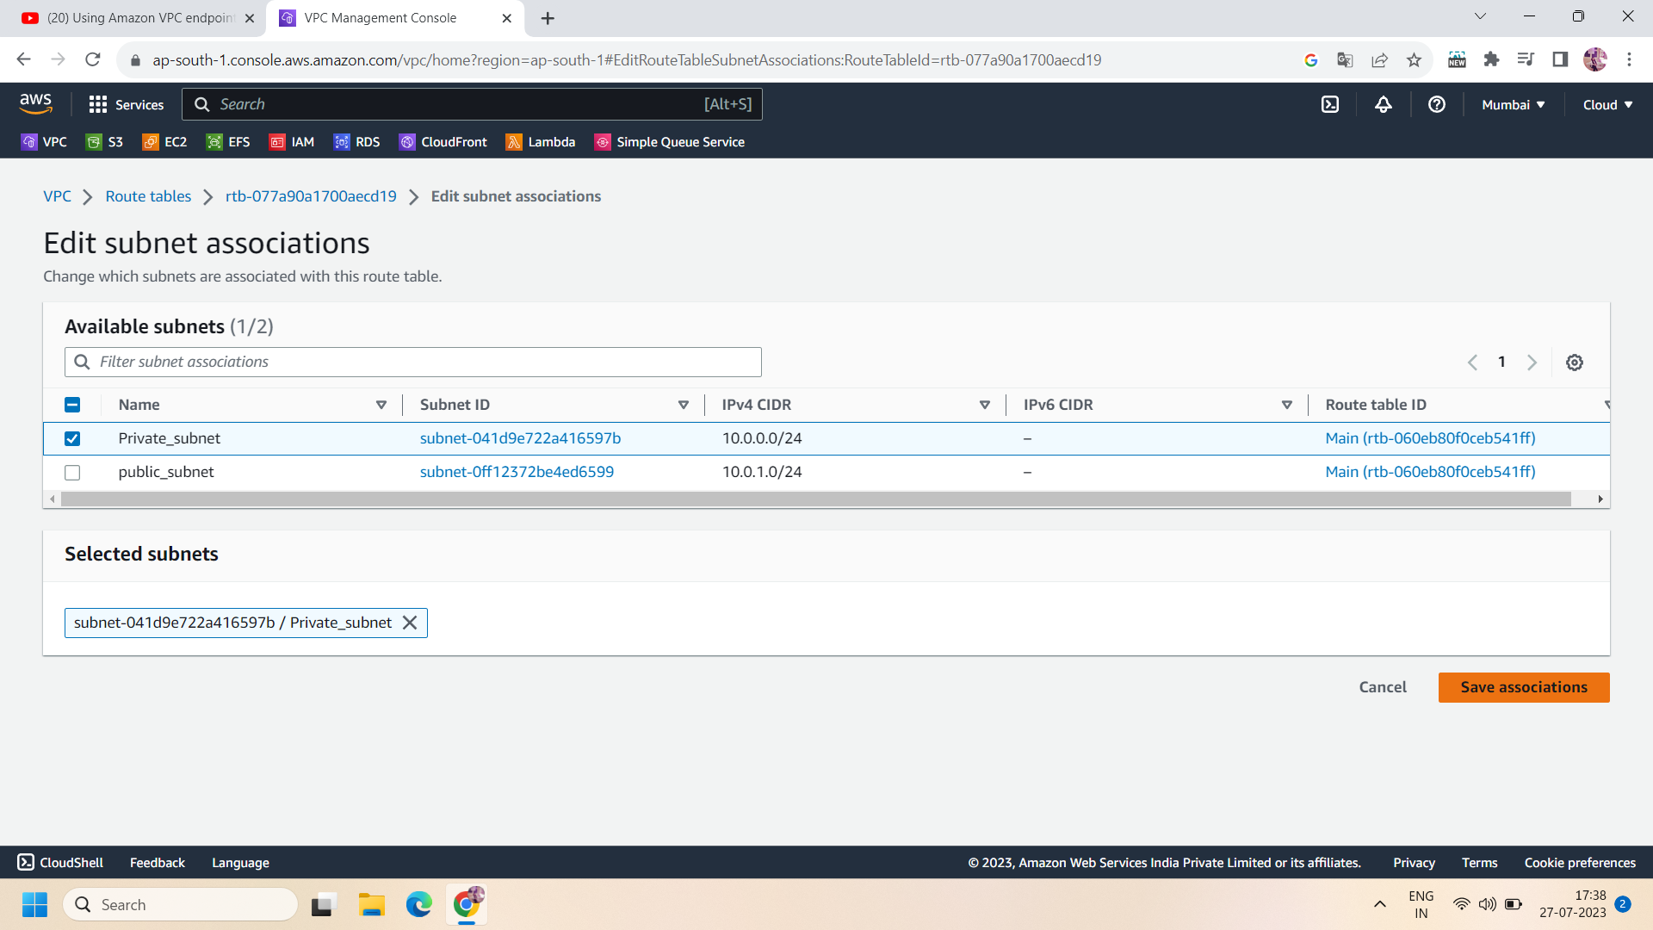

* Creating a public route table —->

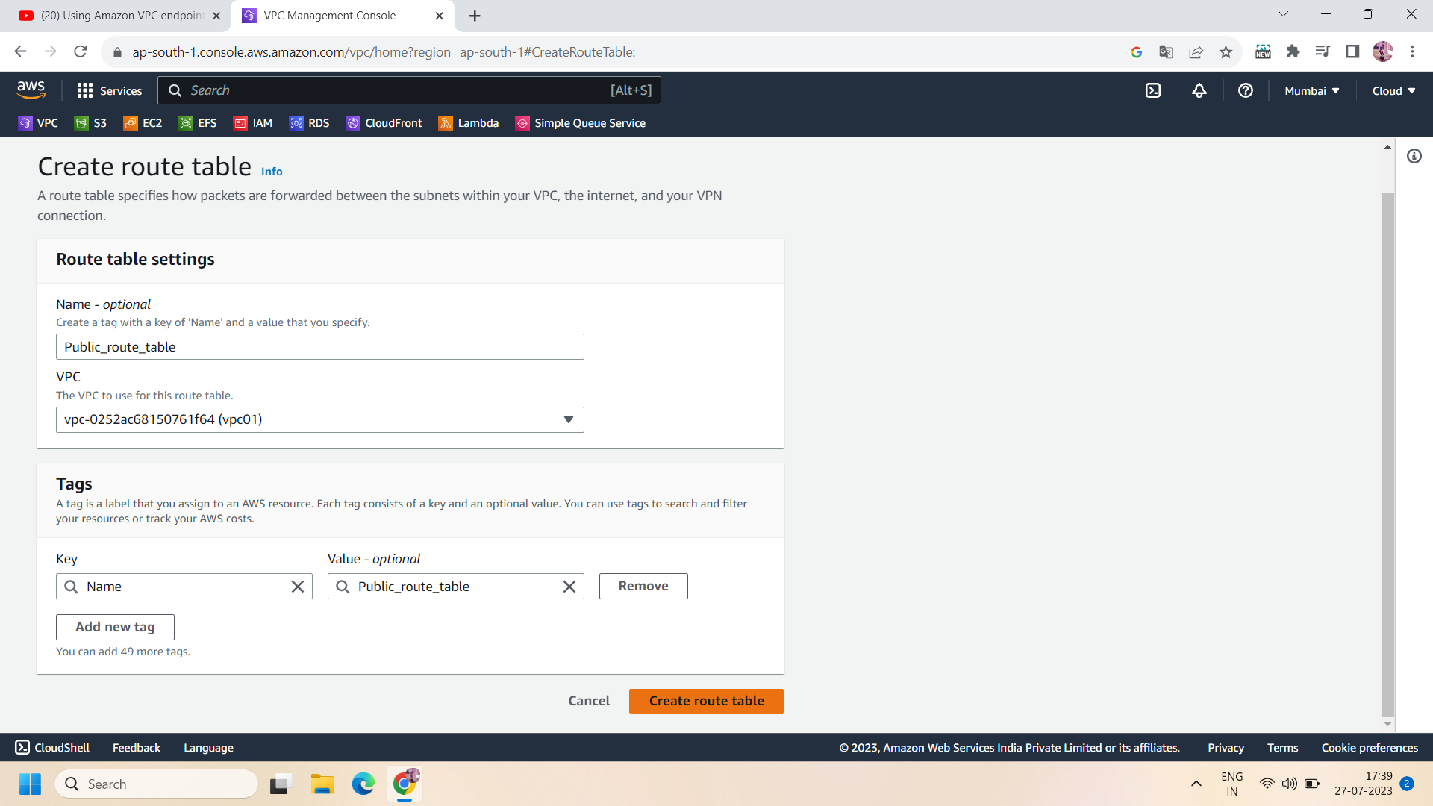

* Now ,associate the public subnet with the public route table.

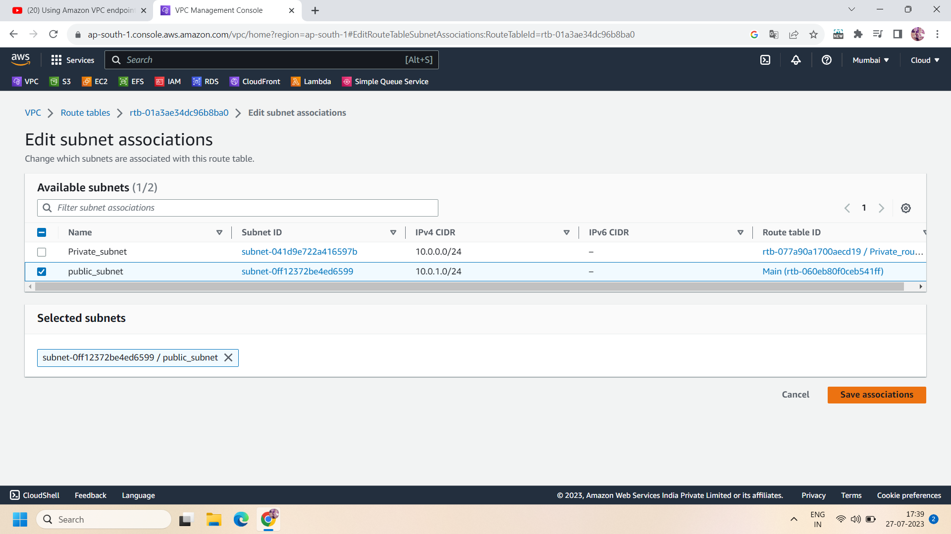

Step 6: Now create an internet gateway to connect with the public route table for allowing incoming traffic.

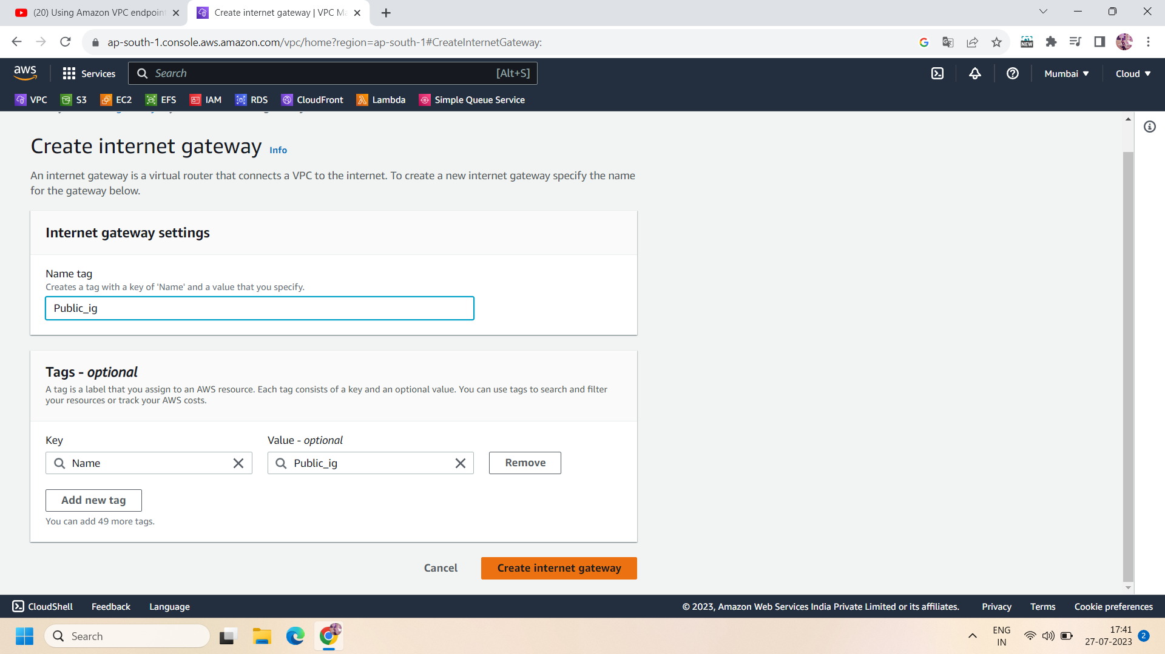

Step 7: After creating IG,click on the public route table and edit the “routes” then add the internet gateway and destination will be 0.0.0.0/0.

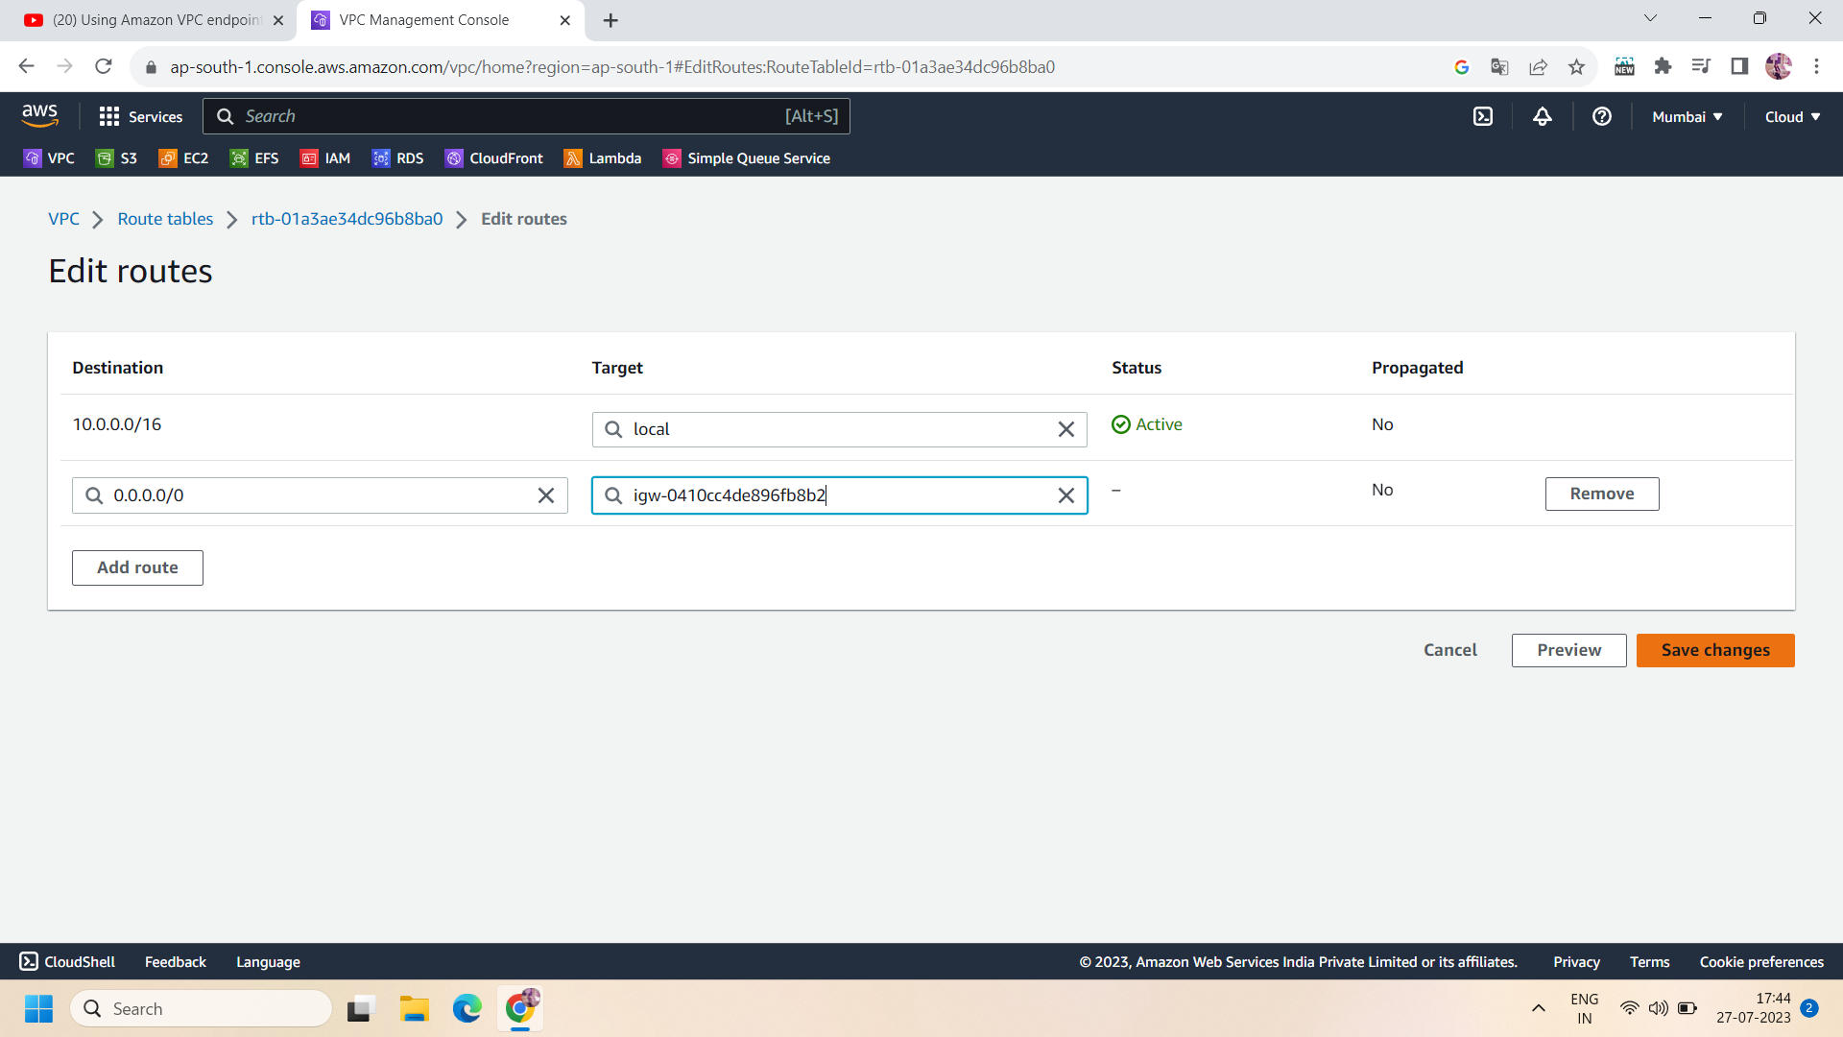

Step 8: Now create two instances : one in private subnet and other one in public subnet with linux server and same VPC but different subnets and enable auto-assign public ip in public subnet and disable auto-assign public ip in case of private subnet.

Security group allow SSH.and then create both the instances with rest default settings.

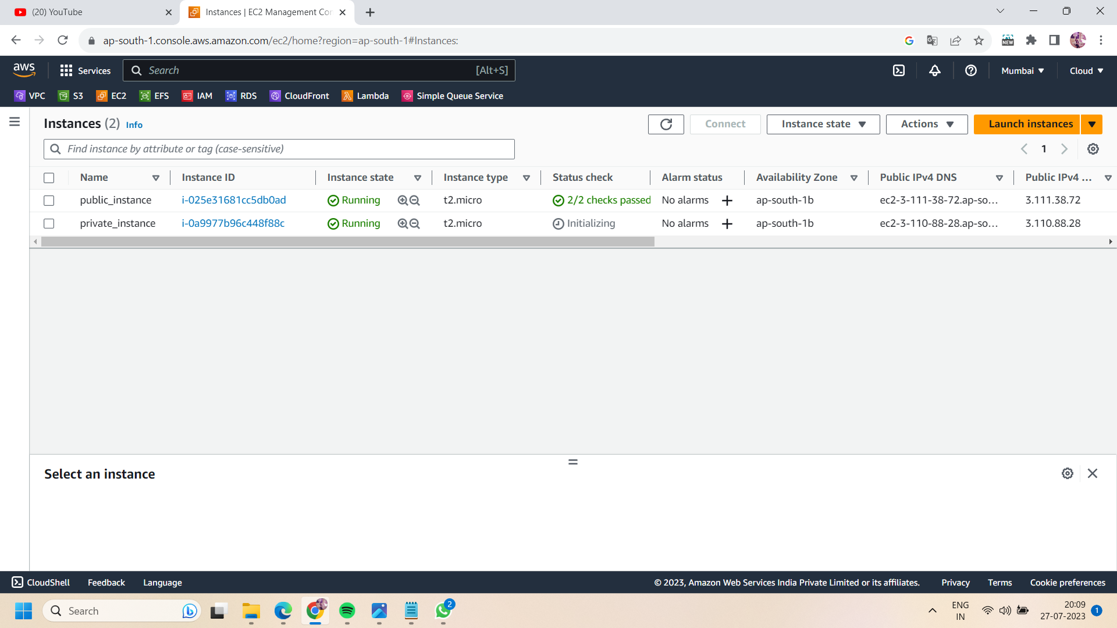

Step 9: now go to IAM roles and create a new role having Dyanmodb full access and click on “update IAM role” then move to ec2 console and select the private instance and click on “actions”---->click on “security” and then —-->click on “Modify IAM role” then add the created IAM role with private subnet.

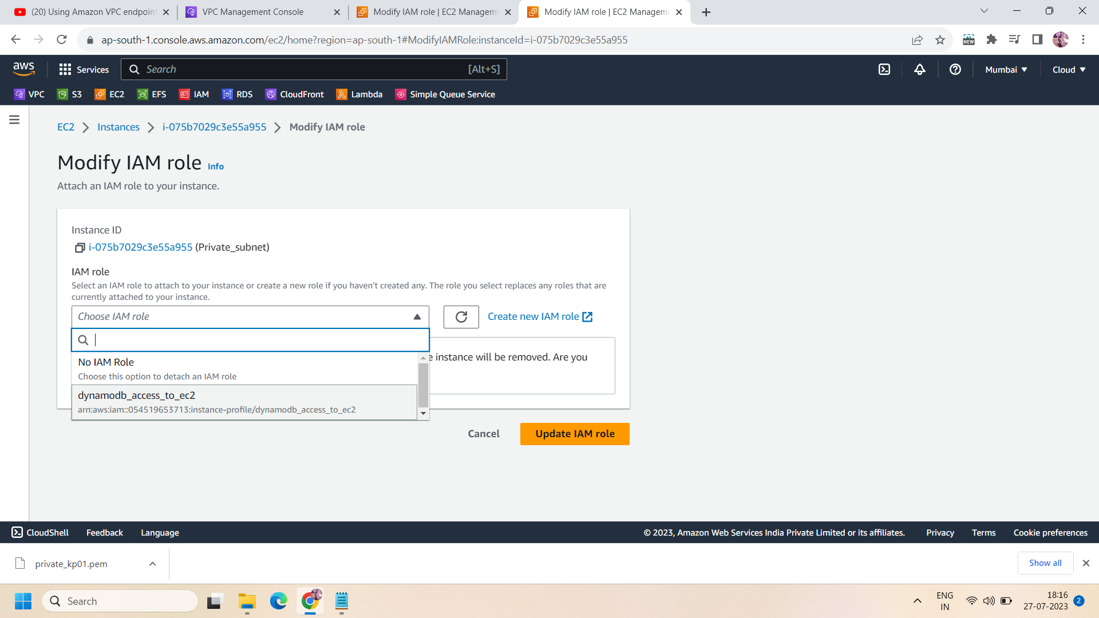

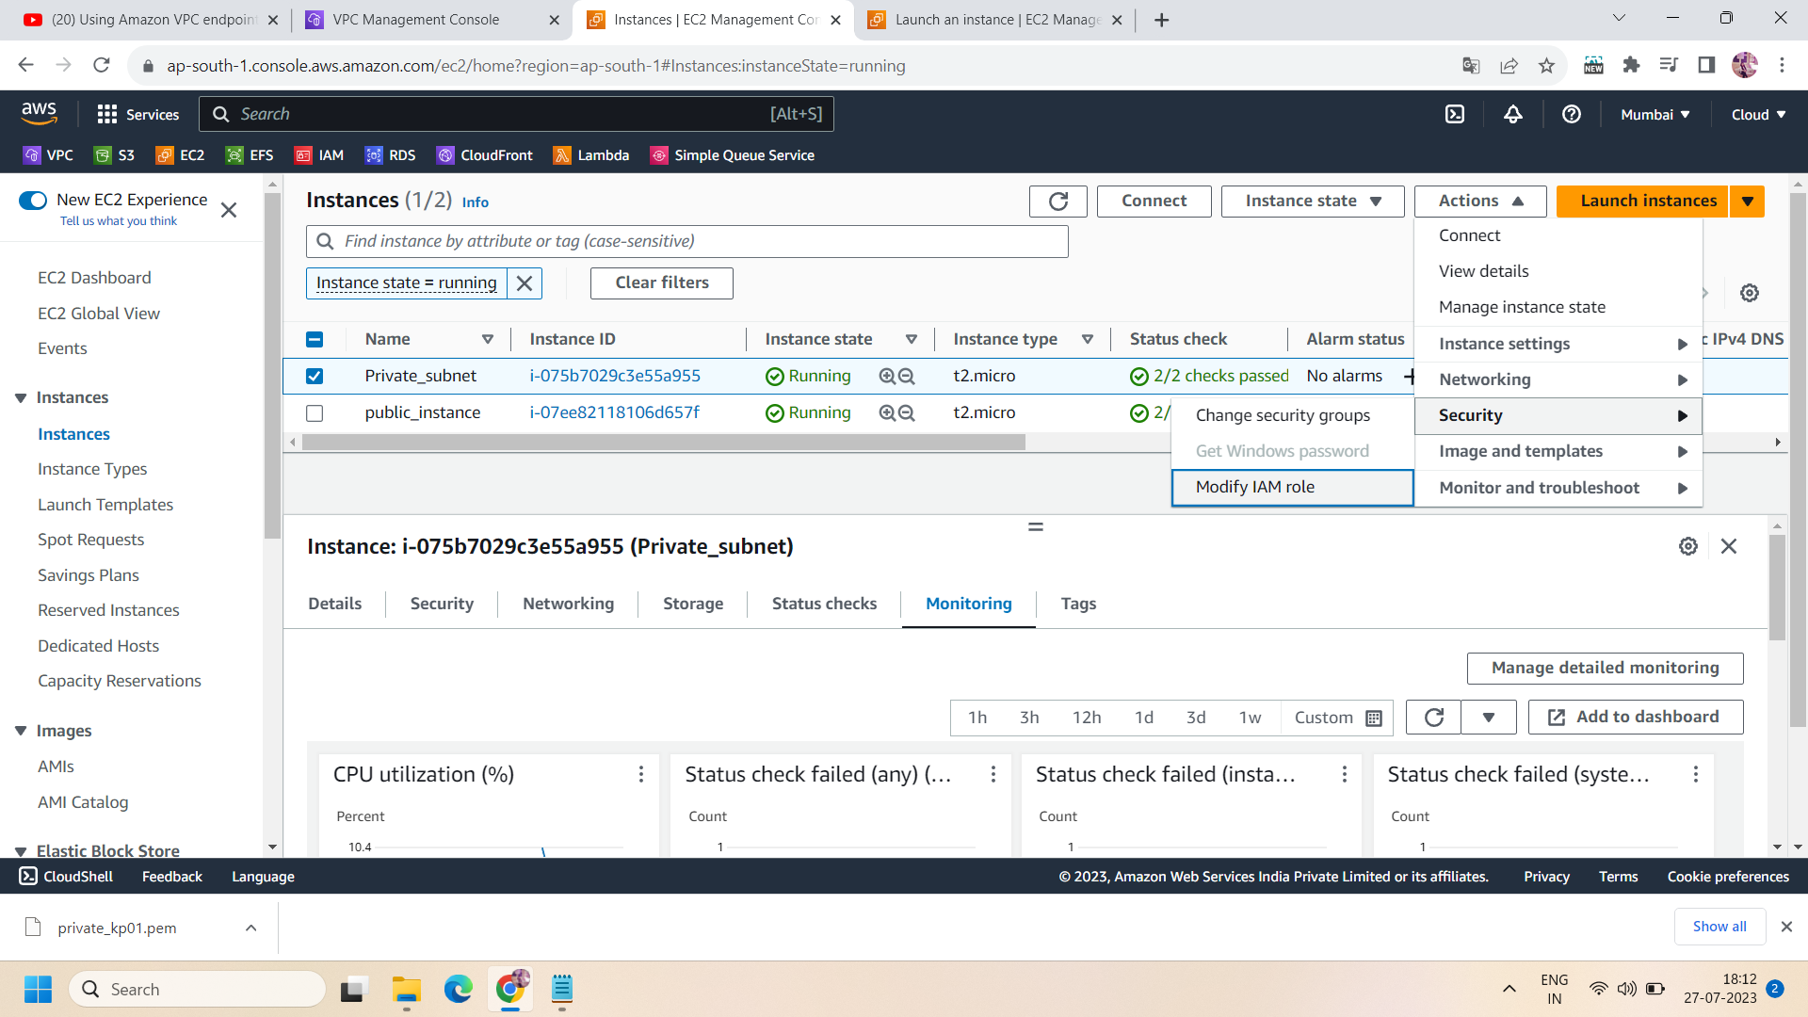

Step 10:Now use any ssh software to take ssh of public instance .Here we use putty and puttygen to connect with the linux server.First go to puttygen and load the downloaded key-pair file here and then save the “private key file” .after that move to putty and browse the saved private key file and paste the public ip of your public instance.

Here we successfully connect to our public instance by login as : ec2-user

To check incoming traffic ,we can run following command :

ping www.google.com

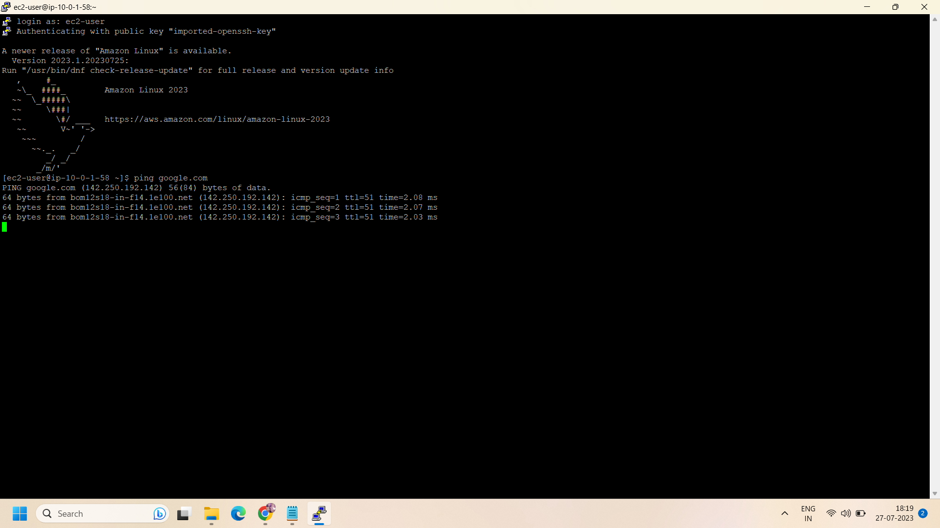

Step 11: To login with private instance into public instance ,run the following command -

* **chmod 400 <key-pair>**

E.g., in our case we have ‘vpc-kp.pem’ key pair file so the command will be :

chmod 400 vpc-kp.pem

* If you get any response then no need to follow nano command otherwise you have to perform nano command too:

**nano <key-pair name>**

* Now ,open your .pem file(key -pair file) into notepad and copy the entire code.
* Paste the entire code into the nano file and then press ctrl + x to save the code.and then exit from the nano dashboard.
* Again run the chmod <key-Pair> command ,this time you will get a response.if not then again run the nano command.

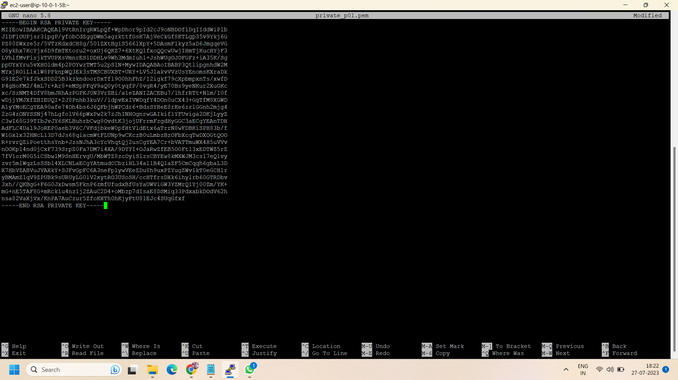

Step 12: Now after successfully following the above steps ,run the ssh command to login as the private instance using a public instance.

* Initially,for public instance -

**ssh -i “<key-pair>” ec2-user@<private-IP of public subnet>**

* Then for private instance -

**ssh -i “<key-pair>” ec2-user@<private-IP of private subnet>**

E.g., we have vpc-kp.prm key pair file and having private ip 10.0.0.106 then we run the command like this: ssh -i "vpc-kp.pem" ec2-user@10.0.0.106

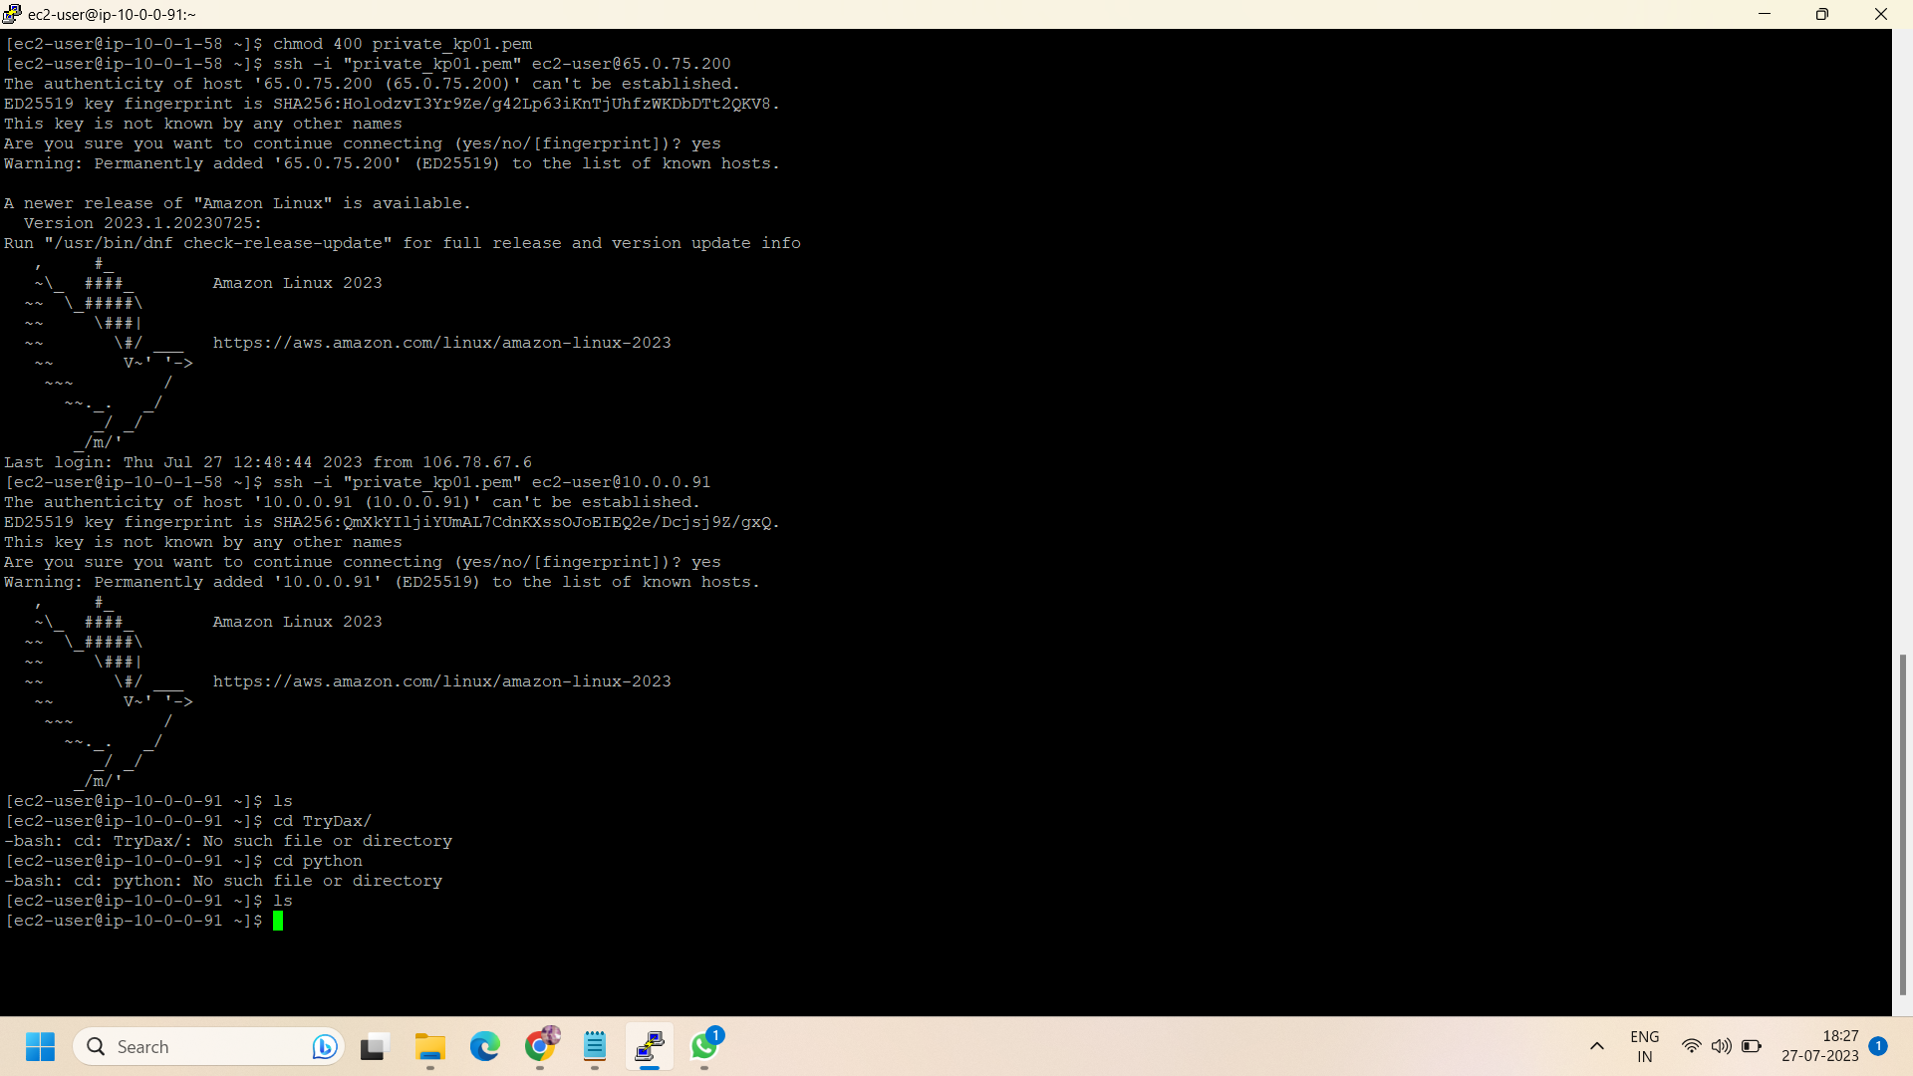

Step 13: Now navigate to the Dynamodb console and create a Dynamodb table:

* Name the Dynamodb table and configure its partition key .here we use student_id as partition key and roll_no as sort key.

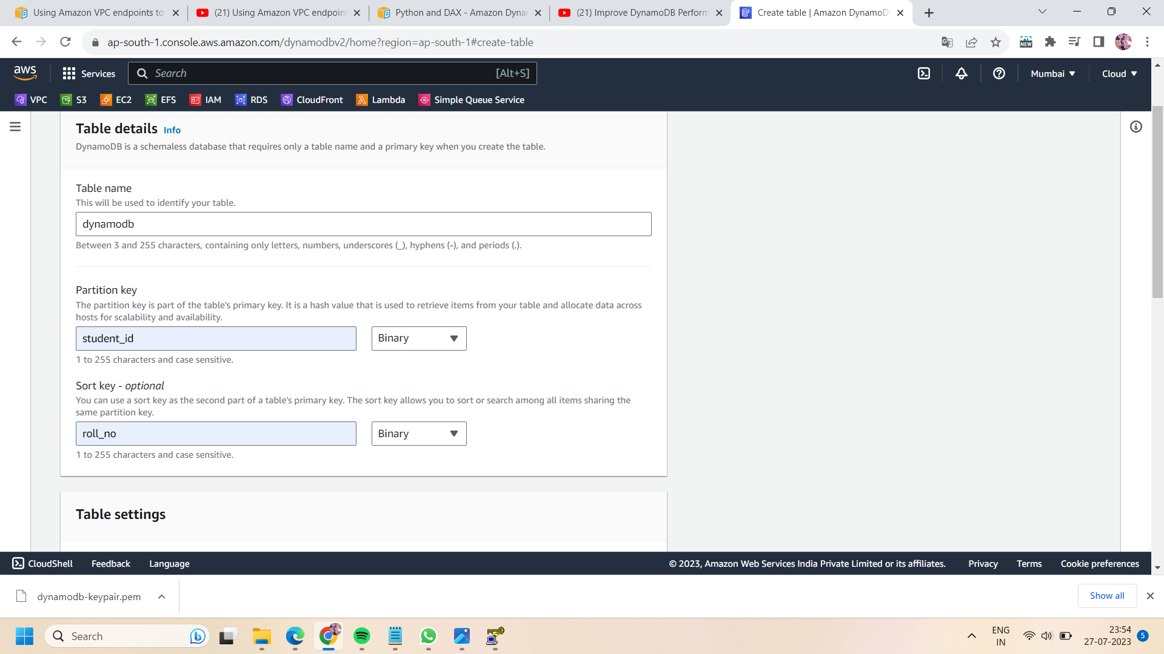

* You can customize the settings but here we don't have any need of any specific settings so we kept it by default.

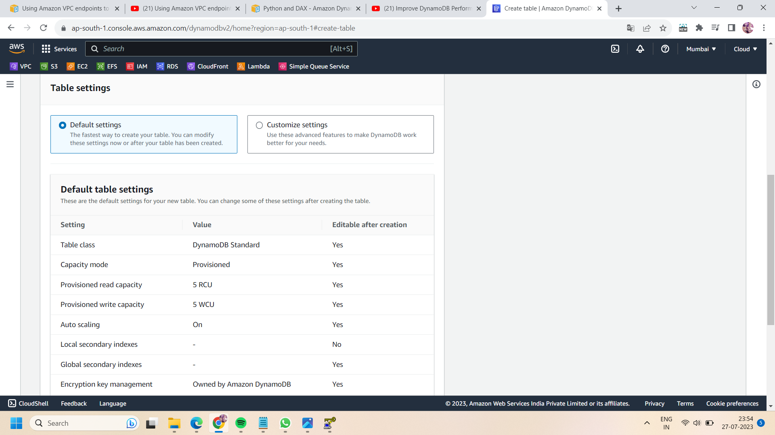

* Now ,click on “create table” after configuring all the settings.

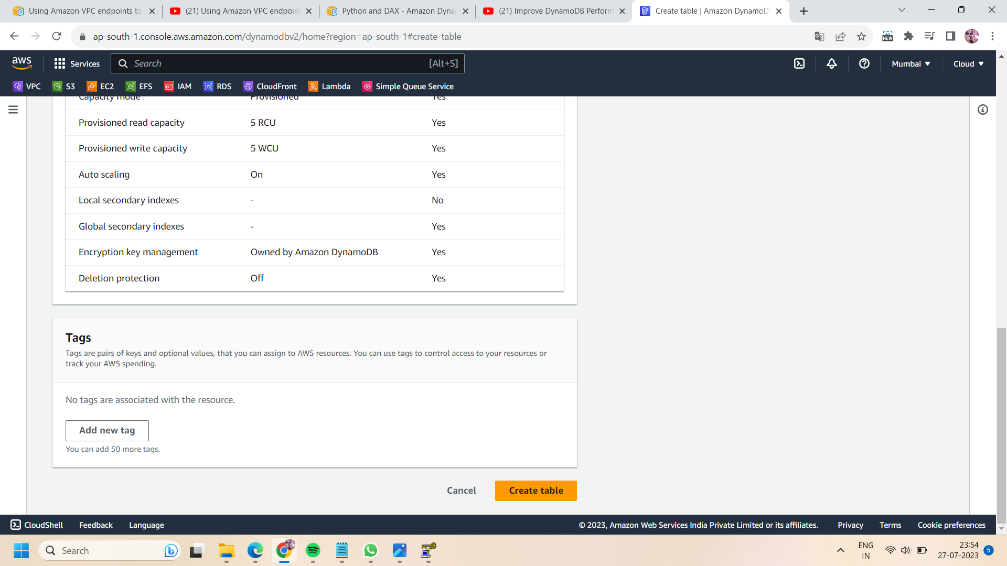

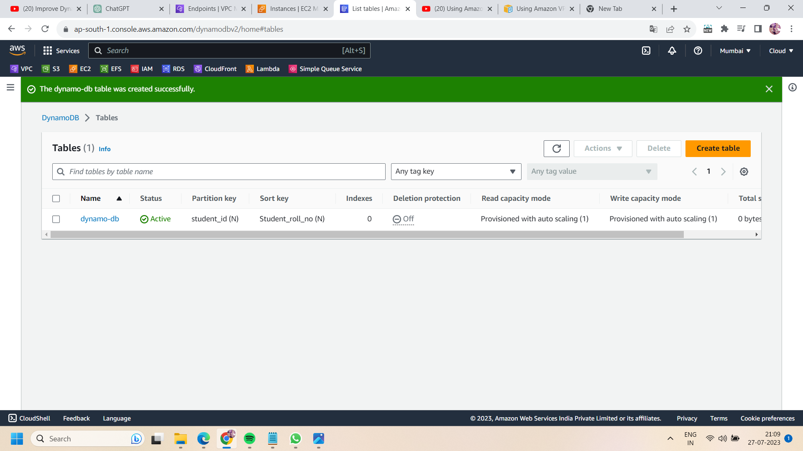

Step 14: Now, go to the VPC endpoint and create a VPC endpoint:

* Configure the aws service and search for Dynamodb and select it.

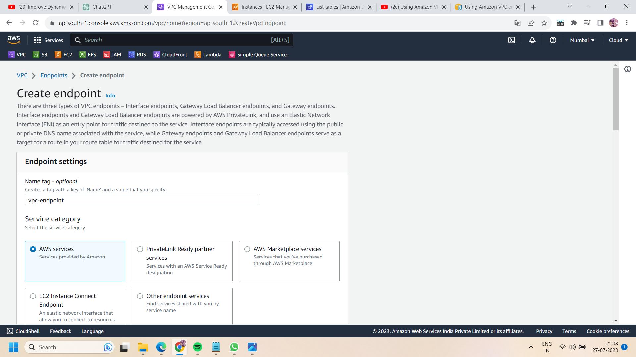

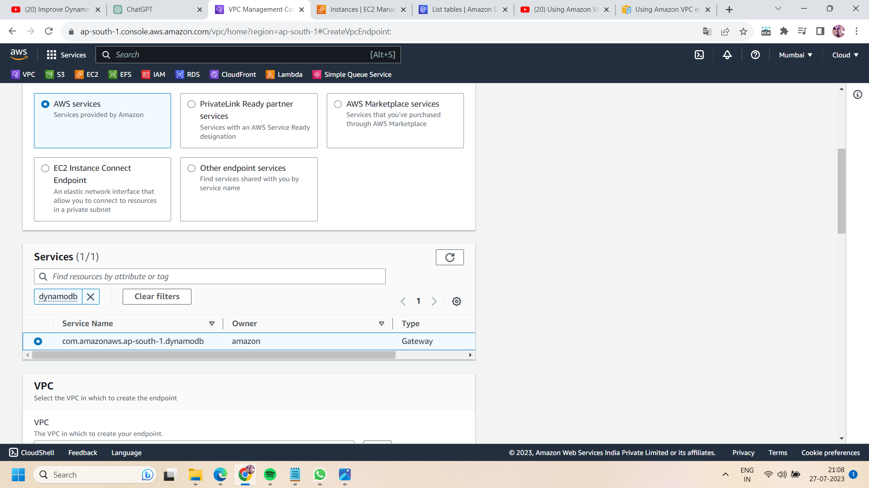

* Select your own VPC and private route table to connect to VPC endpoint.

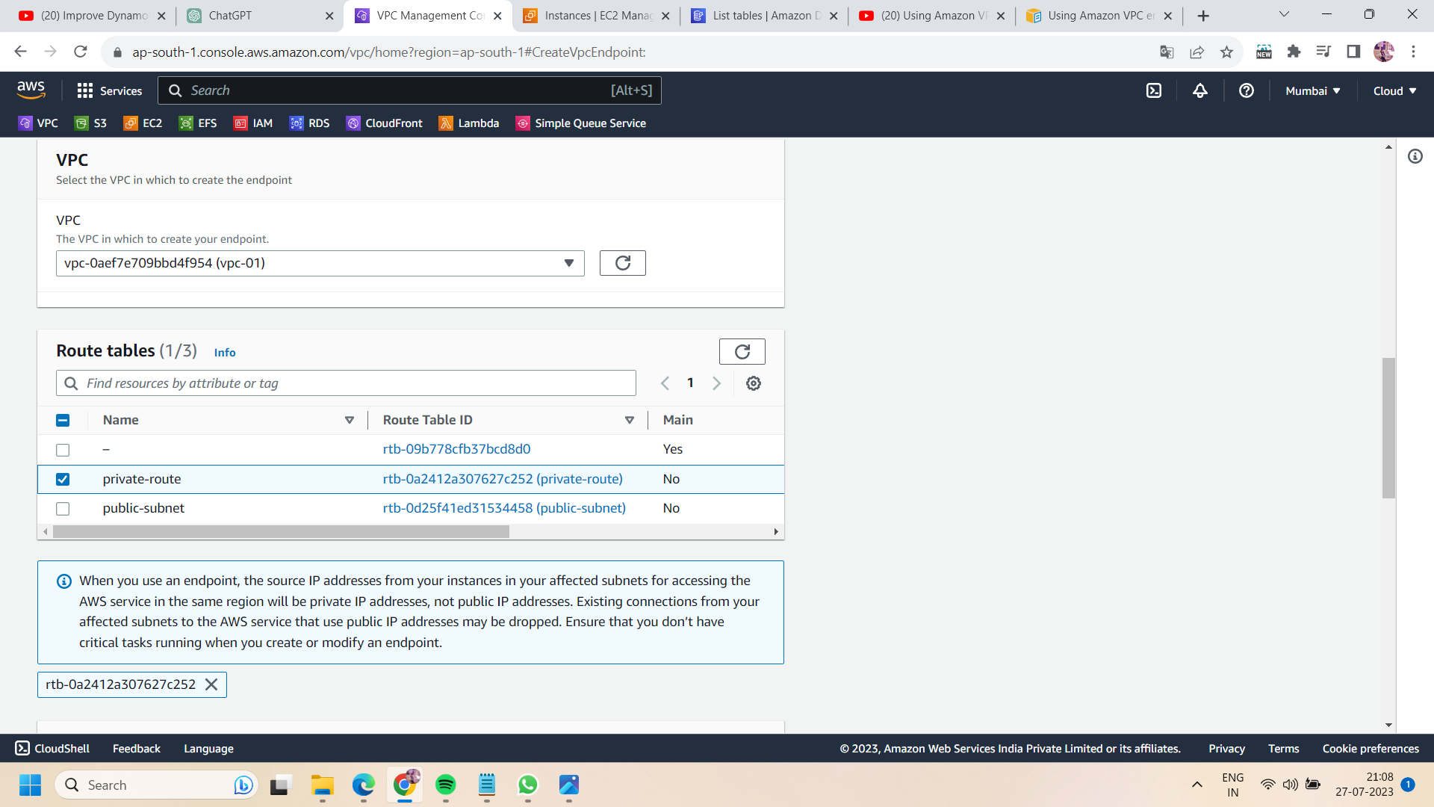

* Provide full access to your VPC endpoint and click on “create endpoint”.

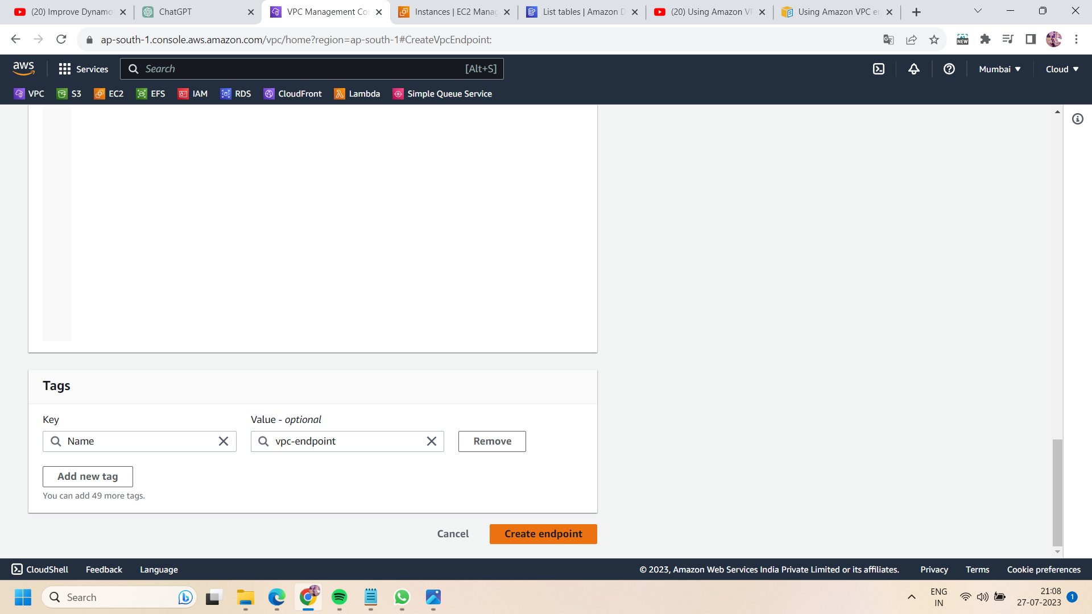

Step 15: now again go to putty session and run the following commands after completing all the above steps:

* Run the command :

**aws dynamodb list-tables** —-> to access the dynamodb table

* But you get no response because first you have specify the region of your dynamodb.For this,run the following command:

**aws configure**

* On run the above command ,specify the region of your Dynamodb .eg., we have a Dynamodb table in us-east-1 region .So I entered us-east-1 and then pressed enter.
* Then again run the command : **aws dynamodb list-tables**
* This time you will get the access of dynamo-db table in specified region.

